

Department of Computer Science and Engineering

A Seminar Report
on

The Evolution and Expansive Role of Computers in Shaping
the Field of Digital Forensics

Submitted in partial fulfillment of the requirements for the award of degree in

Bachelor of Engineering in Computer Science & Engineering

by

Name : Danish Mahajan USN: 1MS20CS037

Under the guidance
of
Darshana A. Naik
Assistant Professor
Department of CSE, MSRIT

M S RAMAIAH INSTITUTE OF TECHNOLOGY
(Autonomous Institute, Affiliated to VTU)
BANGALORE-560054
www.msrit.edu
2023- 2024

Department of Computer Science and Engineering

CERTIFICATE

Certified that the seminar work entitled “The Evolution and Expansive Role of Computers in Shaping
the Field of Digital Forensics” carried out by DANISH MAHAJAN under USN 1MS20CS037 a bonafide student of M.S.Ramaiah Institute of Technology Bengaluru in partial fulfillment for the award of Bachelor of Engineering in Computer Science and Engineering of the Visvesvaraya Technological University, Belgavi during the year 2023-24. It is certified that all corrections/suggestions indicated for Internal Assessment have been incorporated in the report.

Seminar Guide Head of the Department
Darshana A. Naik Dr. Anita Kanavalli

Name of the Examiners: Signature with Date

1.

2.

Department of Computer Science and Engineering

DECLARATION

I, hereby, declare that the entire work embodied in this seminar report has been carried out by Danish Mahajan at M.S.Ramaiah Institute of Technology, Bengaluru, under the supervision of Darshana A. Naik, Assistant Professor, Dept of CSE. This report has not been submitted in part or full for the award of any diploma or degree of this or to any other university.

Signature
DANISH MAHAJAN
1MS20CS037

ACKNOWLEDGEMENT

The satisfaction and euphoria that accompany the successful completion of any task would be incomplete without mention of the people who made it possible and support had been a constant source of encouragement which crowned my efforts with success. I am deeply indebted and would like to express my sincere thanks to our beloved principal Dr. N.V.R Naidu, for providing us an opportunity to do this technical seminar. My special gratitude to Dr. Anita Kanavalli, HOD, Department of Computer science and engineering, RIT for her guidance, constant encouragement and wholehearted support. My sincere thanks to my guide Darshana A. Naik, Assistant Professor, Department of Computer Science and Engineering RIT for his/her guidance, constant encouragement and wholehearted support. Finally, I would like to express my sincere thanks to all the staff members of department of computer science and engineering for their valuable guidance and support.

NAME: DANISH MAHAJAN
USN: 1MS20CS037

Abstract

In this report, we delve into the dynamic landscape of digital forensics, exploring how various fields in computer science, including big data analytics, cloud computing, fast algorithms, DevOps, automation, and networking, alongside Artificial Intelligence (AI), have fundamentally transformed the field. The selection of this topic stems from the increasing reliance on digital technologies, emphasizing the critical need for innovative approaches to investigate cybercrimes effectively. With a focus on the fusion of traditional forensic methods and cutting-edge computer science techniques, this study aims to unravel the intricate ways these disciplines intersect to reshape digital forensics methodologies.

Our research encompasses a broad scope, delving into the technical intricacies of leveraging big data analytics, cloud computing architectures, and advanced algorithms to process vast datasets efficiently. The methodology involves an in-depth analysis of case studies, industry best practices, and emerging technologies. Employing AI-driven algorithms and automation techniques, we investigate how digital footprints are analyzed, potential security threats are identified, and evidence is meticulously preserved. Networking principles are explored to comprehend data transmission patterns, aiding in the identification of cybercriminal activities. Additionally, DevOps methodologies are applied to enhance collaboration and streamline forensic processes, ensuring seamless integration between different stages of investigations.

The findings of our study underscore the transformative impact of integrating diverse computer science disciplines and AI technologies into digital forensics. Through meticulous analysis, we observed a significant improvement in the speed and accuracy of investigations, enabling law enforcement agencies and cybersecurity experts to stay ahead of cyber threats. Furthermore, the synergy between traditional forensic practices and advanced computer science approaches has not only bolstered the efficiency of digital forensics but has also paved the way for more nuanced and insightful conclusions. This report concludes that the amalgamation of computer science fields and AI techniques not only enhances the investigative process but also fortifies the digital realm against evolving cyber challenges.

TABLE OF CONTENTS

Chapter No. Page No.

Declaration iii

Acknowledgements iv

Abstract v

List of Figures vii

List of Tables vii

1 INTRODUCTION
  - General Introduction 1
  - Problem Statement 2
  - Objectives of the seminar 2
  - Current Scope 2

- LITERATURE SURVEY
3.1 Introduction 3
3.2 Related Works with the citation of the References 3
3.3 Conclusion of Survey 4

- RESEARCH GAP ANALYSIS
5.1 Comparative Study of different existing system 5

- SOCIAL IMPACT 6

- CONCLUSION 7

- FUTURE WORK 8

- REFERENCES 9

LIST OF FIGURES

FIGURE NUMBER | TITLE | PAGE NUMBER
1.1 | Taxonomy of digital investigations. | 1
1.2 | Number of Cyber Crime cases registered from 2002 to 2020 | 2

LIST OF TABLES

FIGURE NUMBER | TITLE | PAGE NUMBER
1 | LITERATURE SURVEY | 3

Chapter 1
Introduction

1.1 General Introduction

The rapid evolution of digital technology has ushered in an era of unprecedented connectivity and convenience. However, this digital revolution has also given rise to a myriad of cyber threats and crimes. Digital forensics, the science of uncovering and analyzing digital evidence, has become paramount in combating these cyber challenges. This seminar delves into the intricate amalgamation of traditional investigative methods and cutting-edge computer science techniques, exploring how diverse fields within computer science, including big data analytics, cloud computing, fast algorithms, DevOps, automation, and networking, along with Artificial Intelligence (AI), are reshaping the landscape of digital forensics.

As we know digital investigation is a very vast subject, in this we have different fields like digital investigating techniques, digital forensic readiness, digital evidence, digital offences. The digital investigations tries to tackle offences which mainly occur online, and most of the time user participant in the offences unknowingly or he is the victim and he hasn’t clue about it, some of the offences are financial fraud, cyber theft etc.

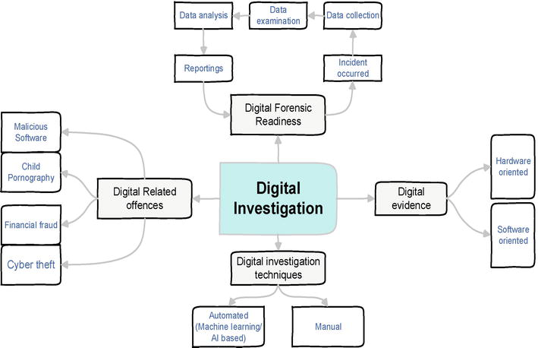
Figure 1.1: Taxonomy of digital investigations.

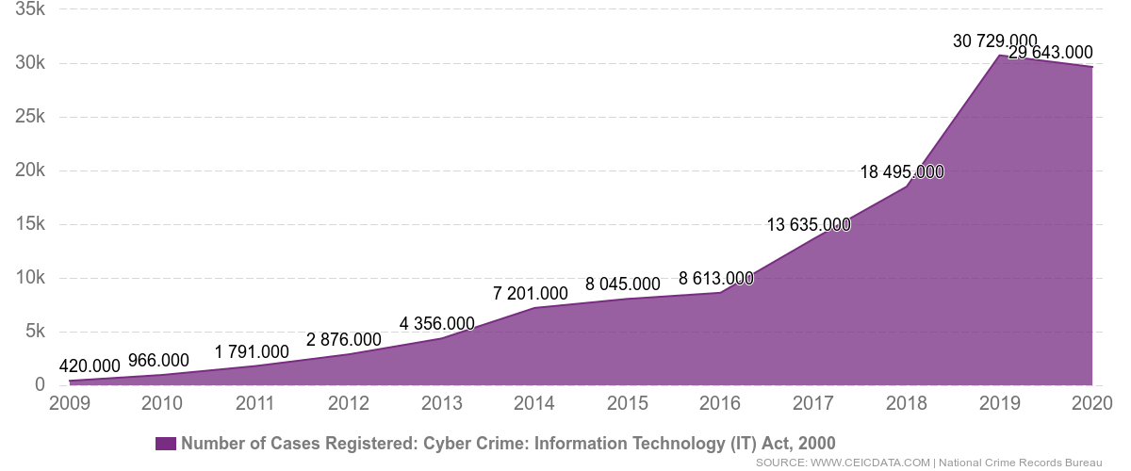
Figure 1.2: Number of Cyber Crime cases registered from 2002 to 2020

1.2 Problem Statement

As digital crimes become increasingly sophisticated, traditional forensic methods struggle to keep pace with the volume and complexity of digital evidence. Investigative agencies face challenges in processing vast datasets, preserving evidentiary integrity, and adapting to rapidly evolving technologies. The need for an innovative, interdisciplinary approach to digital forensics is crucial to address these challenges effectively. This seminar aims to identify the gaps in current forensic methodologies and explore how emerging computer science fields and AI can bridge these gaps, revolutionizing digital investigative practices.

1.3 Objectives of the Seminar

The objectives of this seminar are twofold
- To analyze the evolving role of computers, AI, and various computer science disciplines in digital forensics.
- To provide insights into how the integration of these technologies enhances the efficiency, accuracy, and depth of digital investigations.
By dissecting real-world case studies and industry applications, this seminar seeks to equip attendees with a comprehensive understanding of the symbiotic relationship between computer science and digital forensics, fostering a new era of investigative excellence.

1.4 Current Scope

This seminar focuses on exploring the intersection of computer science and digital forensics, emphasizing the practical applications of big data analytics,iot, cloud computing, fast algorithms, DevOps, automation, networking, and AI in real-world scenarios. By examining the integration of these fields, attendees will gain valuable insights into the tools and methodologies shaping the future of digital investigations. The seminar will also discuss the ethical implications, challenges, and future trends in this evolving landscape, providing a holistic perspective on the expansive role of computers in shaping the field of digital forensics.
Chapter 2
LITERATURE SURVEY

2.1 Introduction

The literature survey in the context of this seminar is a comprehensive exploration of existing research, methodologies, and advancements in the intersection of computer science and digital forensics. This section critically reviews relevant literature to provide a foundation for understanding the current state of the field and to identify gaps or areas where further research and integration are needed.

2.2 Related Works with the Citation of the References
S. NO | Observation
[1]. | This work is one of the earliest efforts to make an application for expert systems for digital forensic to automate the analysis process. The expert system is used with decision tree in order to detect network anomalies automatically. The expert system is used to analyze the log files.
[2]. | Another effort is made by [2] of automating the disk forensic process. They name their tool “fiwalk” which is used to automate the processing of the data in order to assist the user for the development of the program which automatically processes disk images. This tool also integrates the command line tool.
[3] | In this paper, authors has tried to make the tool which uses machine learning techniques to reduce the time taken to find the data in the database.
[4] | In this paper, authors has tried to explain the importance of cloud computing in the digital forensics and tell us that by making the data remote we can easily share the data to other teams and which can help the authority to catch the criminal more fast.
[5] | This paper test many open software to check which software is better for digital forensics.  The aim of this research is to generate distributed snapshot and extract evidences in a forensically sound manner
[6] | In their work, they proposed a semantic approach to search through text-oriented digital evidence in order to sort and search based on certain keywords. The main limitation here is that the method is applicable only to text-based digital evidence which is seldom to be the case, especially in IoT.
[7] | The main idea of their work is based on a hybrid evidence investigation that simultaneously combines both digital and physical evidence from the crime scene to increase verifiability level. Combining both digital and physical evidence from the crime scene could much improve the outcomes of digital forensic investigation yet the legal aspect should be clearly tackled along with the real experimental testing results aiming at proving the usability of the proposed model/system
[8] | As stated before, it is obvious that a forensic model entails a logical breakdown of a computer system into smaller system components that can be manipulated to create or modify forensic procedures
[9] | A comparison between some of the existing frameworks was introduced. To shows the difference between eight frameworks according to eleven different criteria
[10] | This paper aims to provide the in-depth research in machine learning-based on digital forensic investigation

2.3 Conclusion of Survey

The literature survey reveals a rich tapestry of research endeavors, indicating a paradigm shift in digital forensics methodologies. Integrating computer science disciplines such as big data analytics, cloud computing, fast algorithms, and AI has led to significant advancements in the field. These studies collectively underscore the transformative potential of interdisciplinary approaches, emphasizing the need for continued collaboration between computer scientists and forensic experts. However, it is evident that while substantial progress has been made, there remain challenges in standardization, ethical considerations, and the dynamic nature of cyber threats. This survey sets the stage for the subsequent discussions in this seminar, highlighting the existing knowledge base and paving the way for further exploration into the evolving role of computers in shaping the future of digital forensics.

Chapter 3
RESEARCH GAP ANALYSIS

3.1 Comparative Study of Different Existing Systems

One of the notable research gaps identified in the literature is the lack of a comprehensive comparative study of different existing systems in the realm of computer science and digital forensics. While individual studies have explored specific technologies and methodologies, there is a dearth of holistic comparative analyses that assess the strengths, weaknesses, and applicability of these systems across diverse forensic scenarios. Such a study is crucial to provide forensic experts and researchers with a clear understanding of the comparative efficacy of various computer science approaches, including big data analytics, cloud computing architectures, fast algorithms, automation, networking, and AI algorithms.

A comprehensive comparative study can shed light on the following aspects:

- Ethical and Legal Implications: Exploring the ethical and legal implications of implementing various computer science techniques in digital forensics is vital. This includes issues related to privacy, data protection, and the admissibility of evidence in legal proceedings.
- Encryption Technologies: The widespread use of encryption tools poses a significant challenge to digital forensics. Research was needed to develop effective methods to bypass or counter these technologies without violating user privacy rights.
- Cloud Forensics: With the growing adoption of cloud computing, digital evidence is often stored on remote servers. Developing reliable methods for acquiring and preserving evidence from cloud environments was a major research gap
- Data Integrity and Preservation: Ensuring the integrity of digital evidence throughout the forensic process is crucial. Research gaps existed in methodologies for preserving and authenticating digital evidence to maintain its integrity in legal proceedings.
- Network Forensics: Analyzing network traffic for forensic purposes was a complex task, especially in large and high-speed networks. Research focused on developing efficient methods for network forensics to trace malicious activities and attacks.
- Internet of Things (IoT) Forensics: IoT devices generate vast amounts of data, but there was a lack of standardized methods for forensically analyzing these devices.
- Adaptability to Diverse Cases: Assessing the adaptability of existing systems to diverse forensic cases, including cybercrimes, fraud detection, intellectual property theft, and terrorism-related activities, is essential. Variability in data types and sources requires systems that can handle a wide array of digital evidence.
- Human Factor: Investigator skills, training, and experience significantly impact the effectiveness of digital forensics.

By conducting a thorough comparative analysis, researchers can bridge the existing gap in knowledge and provide a roadmap for the development of more efficient, ethical, and legally compliant computer science-driven digital forensics systems. Addressing these research gaps will not only enhance the current understanding of the field but also contribute significantly to the advancement of digital forensic practices.

Chapter 4
SOCIAL IMPACT

The integration of computer science disciplines and artificial intelligence (AI) into digital forensics has far-reaching social implications, shaping both the security landscape and the ways in which society interacts with technology. This section explores the profound social impact of these advancements, touching upon various aspects that influence individuals, communities, law enforcement, and society at large.

- Crime Prevention and Law Enforcement: Digital forensics deters cybercriminals and enhances law enforcement agencies' ability to investigate and solve cybercrimes, ensuring effective crime prevention.
- Legal Processes: Digital forensics provides critical evidence in legal cases, guaranteeing fair trials and aiding in the delivery of justice.
- Cybersecurity: Digital forensics helps organizations respond to cyber attacks, understand their nature, and develop robust cybersecurity measures, ensuring online safety.
- Privacy and Ethics: Digital forensics raises ethical questions about balancing privacy and security, shaping data protection laws and policies while safeguarding civil liberties.
- Business and Economy: Digital forensics reduces economic losses from cybercrimes, mitigates reputational damage, and contributes to the financial stability of businesses.
- Education and Awareness: Digital forensics education programs produce skilled professionals and raise public awareness, ensuring a safer digital environment.
- Policy and Regulation: Digital forensics informs legislation, fosters international cooperation, and plays a key role in the development of cybercrime-related policies and agreements.
- Cyberbullying and Online Safety: Digital forensics tools are instrumental in preventing cyberbullying, protecting vulnerable populations, and ensuring online safety for individuals, especially the youth and seniors.

In summary, the social impact of integrating computer science and AI into digital forensics is multifaceted. It not only enhances security measures and strengthens law enforcement capabilities but also necessitates a broader societal dialogue on digital literacy, privacy, and ethics. By fostering a deeper understanding of these issues, society can harness the benefits of technological advancements while addressing the associated challenges, ultimately creating a safer and more informed digital world.

Chapter 5
CONCLUSION

In conclusion, the integration of diverse computer science disciplines and artificial intelligence (AI) into the field of digital forensics marks a profound evolution, revolutionizing the way society addresses cybercrimes and digital security challenges. The journey through this exploration has revealed a landscape where traditional investigative methods intersect seamlessly with cutting-edge technologies, creating a synergy that empowers forensic experts and law enforcement agencies to combat cyber threats with unparalleled efficiency and precision.

The seminar has shed light on the pivotal role of big data analytics, cloud computing, fast algorithms, automation, networking, and AI in shaping the future of digital forensics. We have witnessed how these technologies enhance the investigative process, from handling massive datasets to recognizing intricate patterns within digital evidence. Moreover, the implementation of machine learning algorithms and deep neural networks has elevated the accuracy of forensic analyses, enabling the identification of cybercriminal activities with remarkable speed and reliability.

This journey has not only emphasized the technical advancements but also highlighted the ethical considerations and social responsibilities associated with digital forensics. Balancing the need for security with individual privacy rights and ensuring the responsible use of AI technologies are challenges that demand continuous vigilance and ethical introspection.

As we move forward, it is imperative for researchers, practitioners, policymakers, and society at large to collaborate, fostering a holistic understanding of the evolving digital landscape. By embracing interdisciplinary approaches and staying abreast of emerging technologies, the field of digital forensics can continue to evolve, ensuring a safer digital environment for individuals, businesses, and communities worldwide.

In essence, this seminar has been a transformative journey, unveiling the limitless possibilities that arise when technology and expertise converge. The integration of computer science and AI in digital forensics not only solves current challenges but also prepares us for the complex digital landscapes of tomorrow. With ongoing research, responsible implementation, and a commitment to ethical practices, the future of digital forensics holds the promise of a safer, more secure digital world for all.

Chapter 6
FUTURE WORK

The intersection of computer science, artificial intelligence (AI), and digital forensics opens avenues for extensive future research and innovation. Several areas warrant exploration to further enhance the effectiveness and scope of digital forensic investigations:
Advancements in AI Algorithms: Future research can focus on developing more sophisticated AI algorithms, particularly in natural language processing and computer vision. Advanced language models and deep learning architectures could lead to more accurate analysis of textual and multimedia evidence, enabling deeper insights into cybercrimes.

Explainable AI (XAI) in Digital Forensics: The integration of explainable AI techniques is vital for ensuring transparency in decision-making processes. Research in XAI can lead to the development of interpretable models, allowing forensic experts to understand and trust the AI-driven conclusions, which is crucial for legal contexts.

Real-time Data Analysis: Developing real-time data analysis tools that can process and analyze data streams as they occur will be essential. This will enable law enforcement agencies to respond rapidly to unfolding cyber threats and take preventive actions in real-time.

Quantum Computing in Cryptanalysis: As quantum computing technology matures, there is a need to explore its applications in cryptanalysis and cybersecurity. Quantum algorithms can potentially break existing encryption methods, prompting the development of quantum-resistant cryptographic techniques to safeguard digital evidence.

Standardization and Protocols: Establishing international standards and protocols for digital forensics procedures, especially in the context of AI-driven analyses, is critical. Standardization can ensure consistency in methodologies and evidence admissibility, enhancing the credibility of digital forensic findings in legal proceedings.

Human-Computer Collaboration: Exploring the synergy between AI and human expertise is a promising area. Human-computer collaboration models, where AI assists forensic experts in decision-making processes, can enhance the overall efficiency of investigations. Research in human-AI interaction can refine these collaborative frameworks.

Ethical Considerations and Bias Mitigation: Addressing ethical considerations surrounding data privacy, biases in AI algorithms, and the responsible use of technology is paramount. Future work should focus on developing frameworks to mitigate biases, ensuring fairness and accuracy in AI-driven forensic analyses.

Cross-Disciplinary Research: Encouraging collaborative research across computer science, law, psychology, and other relevant fields can lead to a more holistic understanding of digital crimes. Interdisciplinary approaches can result in innovative solutions and methodologies that encompass diverse aspects of cybercrimes.
In summary, the future of digital forensics lies in continuous innovation, ethical awareness, and collaborative efforts. By embracing emerging technologies, addressing ethical challenges, and fostering interdisciplinary research, the field can stay ahead of cybercriminals, ensuring the security and integrity of digital spaces in the years to come.

Reference:
[1] Stallard T, Levitt K. Automated analysis for digital forensic science: Semantic integrity checking. In: 19th Annual Computer Security Applications Conference, 2003. Proceedings. IEEE; 2003

[2] Garfinkel SL. Automating disk forensic processing with SleuthKit, XML and python. In: 2009 Fourth International IEEE Workshop on Systematic Approaches to Digital Forensic Engineering. IEEE; 2009

[3] Hoelz BW, Ralha CG, Geeverghese R. Artificial intelligence applied to computer forensics. In: Proceedings of the 2009 ACM Symposium on Applied Computing. ACM; 2009

[4] CSA, “Security guidance for critical areas of focus in cloud computing,” https://cloudsecurityalliance.org/csaguide.pdf, (2009), accessed 22-07-2013.

[5] Sameera Almulla, Youssef Iraqi, Andrew Jones “A Distributed Snapshot Framework for Digital Forensics Evidence Extraction and Event Reconstruction From Cloud Environment”, 2013 IEEE International Conference on Cloud Computing Technology and Science

[6] S. Mascarnes, P Lopes and P. Sakhare, “Search Model for Searching the Evidence in Digital Forensic Analysis,” IEEE - International Conference on Green Computing and Internet of Things (ICGCIoT), pp. 1353-1358, 2015

[7] M. Harbawi and A. Varol, “The Role of Digital Forensic in Combating Cybercrimes,” IEEE – The 4th International Symposium on Digital Forensics and Security (ISDFS 2016), pp. 138-142, 2016.

[8] Leigland, R., and Krings, A. W., “A Formalization of Digital Forensics”, International Journal of Digital Evidence, Vol. 3, No. 2, pp. 1-32, 2004.

[9] Scholtz, J., and Narayanan, J., “Towards an Automated Digital Data Forensic Model with Specific Resssference to Investigation Processes”, the 8th Australian Digital Forensics Conference, pp. 142-155, 2010

[10] Salman Iqbal and Soltan Abed Alharbi “Advancing Automation in Digital Forensic Investigations Using Machine Learning Forensics”.

